Week 4

1st

* **Overview of Optimization in Data Science**: The lectures focus on the significance of optimization in data science, introducing various types of optimization problems relevant to the field.
* **Types of Optimization Problems**:
  + **Unconstrained Non-linear Optimization**: Finding the best solution without restrictions on decision variables.
  + **Constrained Non-linear Optimization**: Finding solutions while adhering to specific constraints on decision variables.
* **Three Pillars of Data Science**:
  + **Linear Algebra**
  + **Statistics**
  + **Optimization**: Essential for understanding data science algorithms.
* **Definition of Optimization**: Optimization is defined as maximizing or minimizing a real function by systematically selecting input values from an allowed set.
* **Key Components of Optimization Problems**:
  + **Objective Function (f)**: The function to be maximized or minimized.
  + **Decision Variables (x)**: The variables we can control to optimize the function.
  + **Constraints**: Restrictions that limit the values of decision variables.
* **Importance of Optimization in Data Science**:
  + **Function Approximation**: Minimizing error in regression problems.
  + **Classification**: Finding the best hyperplane to separate data points from different classes.
* **Machine Learning and Optimization**: Most machine learning algorithms can be interpreted as solutions to optimization problems, making a solid understanding of optimization crucial for interpreting results and developing new algorithms.
* **Types of Optimization Problems**:
  + **Linear Programming**: Continuous variables with linear objective and constraints.
  + **Non-linear Programming**: Either the objective function or constraints are non-linear.
  + **Integer Programming**: Decision variables are restricted to integer values.
  + **Mixed Integer Programming**: Combination of continuous and integer variables.
* **Univariate Optimization**: Involves optimizing a function with a single decision variable, distinguishing between local and global minima.
* **Convex Functions**: Functions with a single minimum point, which can be both local and global minima.

This summary encapsulates the core concepts and significance of optimization in data science, emphasizing its foundational role in various applications and algorithms.

**Summary and Key Points of Optimization in Machine Learning**

Machine learning algorithms often solve optimization problems, even when their origins are in other fields like biology. Understanding optimization helps in interpreting machine learning results and could lead to developing new algorithms.

**Components of an Optimization Problem**

1. **Objective Function (f)**: The function to be minimized or maximized. Most problems focus on minimization because maximization can be converted into minimization by changing the sign.
2. **Decision Variables (X)**: Variables we adjust to minimize the objective function.
3. **Constraints**: Conditions that limit the values the decision variables can take.

**Types of Optimization Problems**

1. **Linear Programming**:
   * Objective function and constraints are linear.
   * Decision variables are continuous.
2. **Non-linear Programming**:
   * Objective or constraints are non-linear.
   * Can be convex (easier to solve) or non-convex (harder to solve).
3. **Integer Programming**:
   * Decision variables are integers.
   * If linear, called Linear Integer Programming. If non-linear, called Non-linear Integer Programming.
4. **Mixed Integer Programming**:
   * Combination of continuous and integer variables.
   * Can be linear or non-linear.
5. **Binary Integer Programming**:
   * Decision variables take binary values (0 or 1).

**Convexity in Optimization**

* **Convex Functions**: Only one global minimum; easy to solve.
* **Non-Convex Functions**: Multiple local minima, challenging to find the global minimum.
  + Key issue in many algorithms, including early neural networks.
  + Improved algorithms and techniques now help find better solutions.

**Local vs Global Minima**

* **Local Minimum**: Best solution in a small region but not necessarily the best overall.
* **Global Minimum**: Best solution across all possible regions.
  + The challenge arises in finding the global minimum, especially in non-convex problems.

**Importance in Data Science**

* Optimization underpins many machine learning algorithms.
* Issues like initialization can lead to different results each time an algorithm runs, particularly in non-convex problems.

**Conditions for Minimization**

1. **First Derivative = 0**: The function's slope is zero at the minimum.
2. **Second Derivative > 0**: The function is concave up at the minimum.

Understanding these principles helps improve the ability to interpret machine learning models, create better algorithms, and solve more complex problems in various fields.

2nd

**Summary of Multivariate Optimization Process:**

1. **Partial Derivatives & Hessian Matrix**:
   * Compute the first-order partial derivatives ∂f∂x1\frac{\partial f}{\partial x_1}∂x1​∂f​ and ∂f∂x2\frac{\partial f}{\partial x_2}∂x2​∂f​ to find the critical points.
   * Construct the **Hessian matrix** using second-order partial derivatives to assess the curvature of the function.
2. **Eigenvalue Analysis**:
   * The eigenvalues of the Hessian matrix help determine the nature of the critical point:
     + **Both eigenvalues positive**: Local minimum.
     + **Both eigenvalues negative**: Local maximum.
     + **Mixed signs**: Saddle point.
3. **Linear Equations**:
   * If the system of equations is linear (two equations in two variables), it has a unique solution.
4. **Unconstrained vs. Constrained Optimization**:
   * In unconstrained optimization, you directly solve for the minimum or maximum.
   * Next topics include **constrained optimization**:
     + **Equality constraints**: Solutions must satisfy equations.
     + **Inequality constraints**: Solutions must stay within certain bounds.

**Key & Important Points:**

* **Hessian matrix and eigenvalue computation** are essential for determining the nature of critical points.
* **Eigenvalues**: Positive eigenvalues indicate a minimum, a crucial result for optimization.
* **Constrained optimization**: The upcoming lectures will deal with more complex cases involving constraints (equality and inequality), important for real-world problems.

3rd

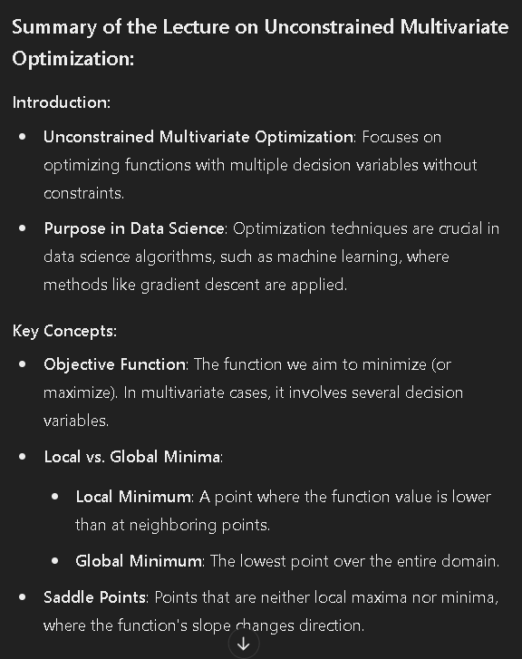

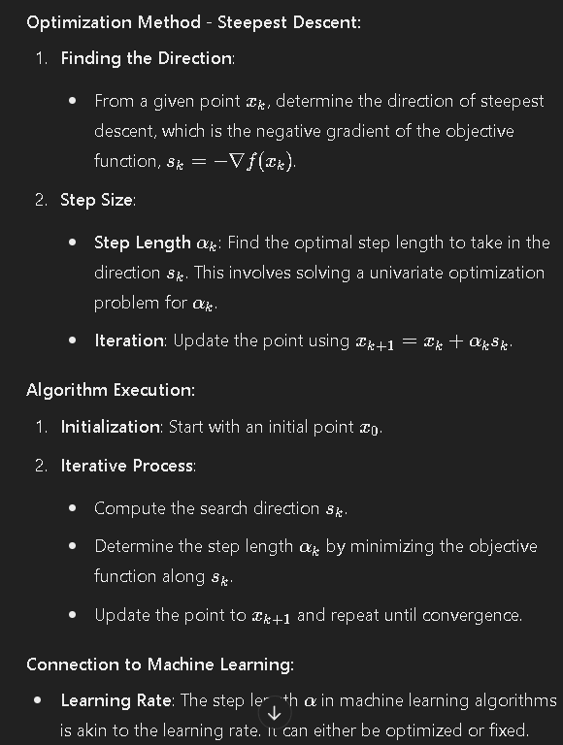

#### Connection to Machine Learning:

* **Learning Rate**: The step length α\alphaα in machine learning algorithms is akin to the learning rate. It can either be optimized or fixed.
* **Gradient Descent in Practice**: Used in various machine learning algorithms, including neural networks and clustering.

#### Conclusion:

* The lecture discussed numerical methods for solving unconstrained multivariate optimization problems, focusing on the steepest descent method and its connection to machine learning techniques. The next lecture will include a numerical example to illustrate these concepts further.

4th

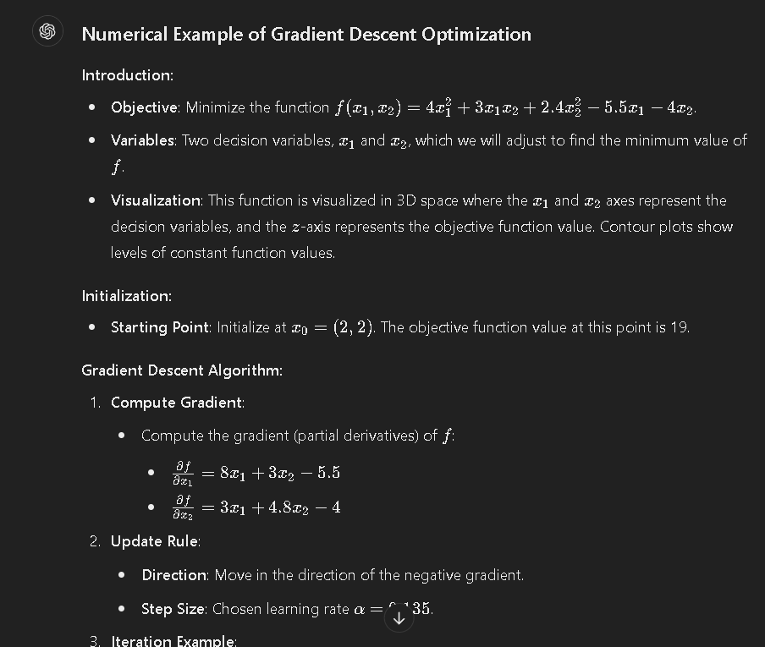

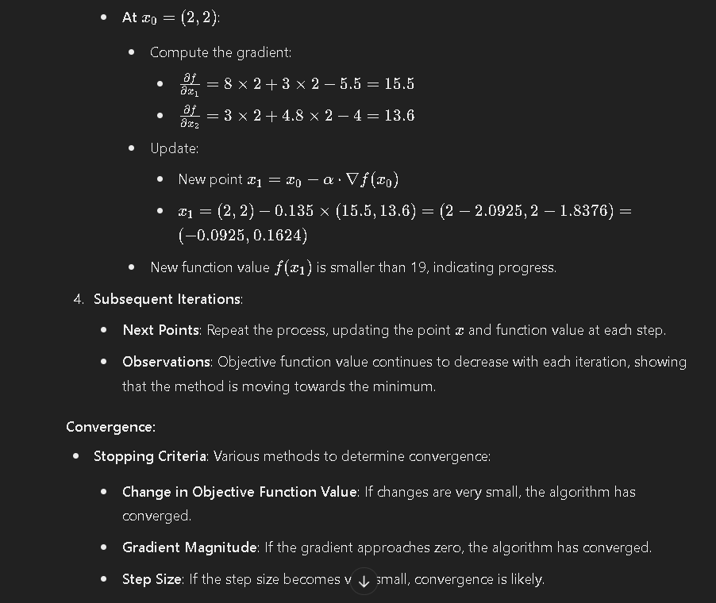

#### Connection to Machine Learning:

* **Learning Rule**: Gradient descent is used to optimize parameters in machine learning models. The learning rate adjusts the size of the steps in each iteration.
* **Error Reduction**: In machine learning, the goal is to minimize error, similar to minimizing the objective function here.

#### Conclusion:

* **Gradient Descent**: Demonstrated as a practical tool for optimization, showing how the method iteratively improves objective function values.
* **Next Steps**: Introduction of constraints into optimization problems, such as equality and inequality constraints, in future lectures.